A Question of Loyalties: Mount Welby During the War of 1812 (Political Systems)

Overview
Oxon Cove Park has a rich history that includes the story of the Debutts, a British family that came to America in the late 1700s. The Debutts family finally settled on a hilltop overlooking the Potomac River that today is known as Oxon Cove Park. It is from this hilltop that Mrs. DeButts witnessed the British capture of Alexandria and the Burning of Washington. The family even found Congreve Rockets on this hill!

Objective(s)
Students will identify and explain the principles of the United States government expressed in stories, symbols, poems, songs, and landmarks.
Students will interpret fiction and non-fiction passages about people, places, and events related to the American political system.

Background
Dr. & Mrs. Debutts
Samuel DeButts was born in Ireland in 1756. He began his career as a doctor in England and there he met and married his wife, Mary Welby, in 1785. Samuel's practice was difficult, unprofitable, and kept the couple apart for weeks. Like hundreds of thousands of other European families, Samuel and Mary decided to immigrate to the United States to make a better life for their family.
Twenty years after the DeButts family arrived in America, Samuel signed a deed for a 206 acre land that is known today as Oxon Hill Farm. Samuel, however, named the new family home Mount Welby, in honor of his wife's family, and spent the rest of his days there. Samuel's grandchildren sold the property in 1843.

War Comes to Mount Welby
During the War of 1812, British troops fought a battle with American Soldiers near Bladensburg, Maryland. The battleground was about ten miles from Mount Welby, the 19th century name of the Oxon Hill Farm property, just east of the current boundaries of Washington D.C.
The British routed the American defenders and marched into the city. By 9 p.m. the U.S. Capitol was ablaze. Two hours later, British soldiers reached the White House and set it afire, along with the Treasury Building next door. Even closer, the Navy Yard in southwest Washington was put to the torch about 8 p.m. to keep ships, ammunition, sails, rope, and other supplies from the British. President James Madison, First Lady Dolly Madison, and many Washingtonians has fled the city only a few hours before.
In 1815, Mrs. DeButts related in a letter to her brother, Richard, her fears of being so close to the scene of the battle.
"The termination of the war has cheered the Hearts of thousands but its bitter consequences will long be severely felt. I cannot express to you the distress it has occasioned at the Battle of Bladensburg. We heard every fire (that place being not more than 5 or 6 miles from us). Our house was shook repeatedly by the firing upon forts & bridges, & illuminated by the fires in our Capital."
The Burning of Washington, D.C.
“I cannot express to you the distress it has occasioned at the Battle of Bladensburg. We heard every fire....Our house was shook repeatedly by the firing upon forts and bridges, and illuminated by the fires in our Capital”
-Mary DeButts writing her sister, Millicent, on March 18, 1815

During the War of 1812, British troops fought a battle with American soldiers and militia near Bladensburg, Maryland. The battleground was about ten miles from here, just east of the current boundaries of Washingon, D.C. The British routed the American defenders and marched into the city on August 24, 1814. By 9 p.m., the U.S. Capitol was ablaze. Two hours later, British soldiers reached the White House and set it afire, along with the Treasury Building next door. Even closer, the Navy Yard in southwest Washington was put to the torch about 8 p.m. to keep ships, ammunition, sails, rope, and other supplies from the British. President James Madison, First Lady Dolley Madison, and many Washingtonians had fled the city only a few hours before. The DeButts family could see the city in flames from this bluff. You will be looking in the same direction if you can see the top of the Washington Monument through the trees. (The DeButts Family didn’t see the monument, because it was not completed until 1884.)

Rockets on the Hill
“We found three rockets on our hill evidently pointed at our house but fortunately did not reach it.”
-Mary DeButts writing her sister, Millicent, on March 18, 1815

Samuel and Mary DeButts were lucky not to be home when three Congreve rockets landed on their farm. By all accounts, the rockets were terrifying. They spewed flames and sparks in flight, changed direction unpredictably, roared as they flew by, and often exploded overhead, showering down hot fragments and powder. The rockets were named for their inventor, William Congreve of Great Britain. They were light, had a range of more than a mile, and did not recoil like a cannon, which made them easy to fire from the deck of a ship. Although they petrified soldiers and citizens who had never seen them before, and sometimes caused fires where they landed, they usually did less damage than a cannonball. Despite Mary DeButts’s worries, the rockets probably were not aimed at her house. They might have been a signal to other British ships anchored some twenty miles away in the Patuxent River. Congreve rockets have a special place in American history. They supplied the “red glare” that Francis Scott Key remembered as he wrote the poem “The Star -Spangled Banner.”

My Dear Milly
The termination of the war has cheered Hearts of thousands but its bitter consequences will long be severely felt. I cannot express to you the distress it has occasioned at the Battle of Bladensburg we heard every fire (that place being not more than 5 or 6 miles from us). Our House was shook repeatedly by the firing upon forts & Bridges, & illuminated by the fires in our Capital. It was indeed a Day & Night of horrors, the fleet debarkment [sic] from Admiral Cockburn’s fleet lay directly before our House. The Capitulation of Alexandria & the result you must have seen in the Public Papers. We left home for Loudoun while the British Vessels were in our River, passing in the ferry Boat close to them without being molested; you know not how it hurt me to think I was so near my Country men, & must look upon them as Enemy, whom I should have rejoiced to have shown every attention to; we found three Rockets on our Hill evidently pointed at our House but fortunately did not reach it
Fr yr ever affectionate
M.D.B.
The Star Spangled Banner Lyrics By Francis Scott Key 1814
Oh, say can you see by the dawn's early light
What so proudly we hailed at the twilight's last gleaming?
Whose broad stripes and bright stars thru the perilous fight,
O'er the ramparts we watched were so gallantly streaming?
And the rocket's red glare, the bombs bursting in air,
Gave proof through the night that our flag was still there.
Oh, say does that star-spangled banner yet wave O'er the land of the free and the home of the brave?

On the shore, dimly seen through the mists of the deep,
Where the foe's haughty host in dread silence reposes,
What is that which the breeze, o'er the towering steep,
As it fitfully blows, half conceals, half discloses?
Now it catches the gleam of the morning's first beam,
In full glory reflected now shines in the stream:
'Tis the star-spangled banner!
Oh long may it wave
O'er the land of the free and the home of the brave!

And where is that band who so vauntingly swore
That the havoc of war and the battle's confusion,
A home and a country should leave us no more!
Their blood has washed out their foul footsteps' pollution.
No refuge could save the hireling and slave
From the terror of flight, or the gloom of the grave:
And the star-spangled banner in triumph doth wave
O'er the land of the free and the home of the brave!

Oh! thus be it ever, when freemen shall stand
Between their loved home and the war's desolation!
Blest with victory and peace, may the heav'n rescued land
Praise the Power that hath made and preserved us a nation.
Then conquer we must, when our cause it is just,
And this be our motto: "In God is our trust."
And the star-spangled banner in triumph shall wave
O'er the land of the free and the home of the brave!

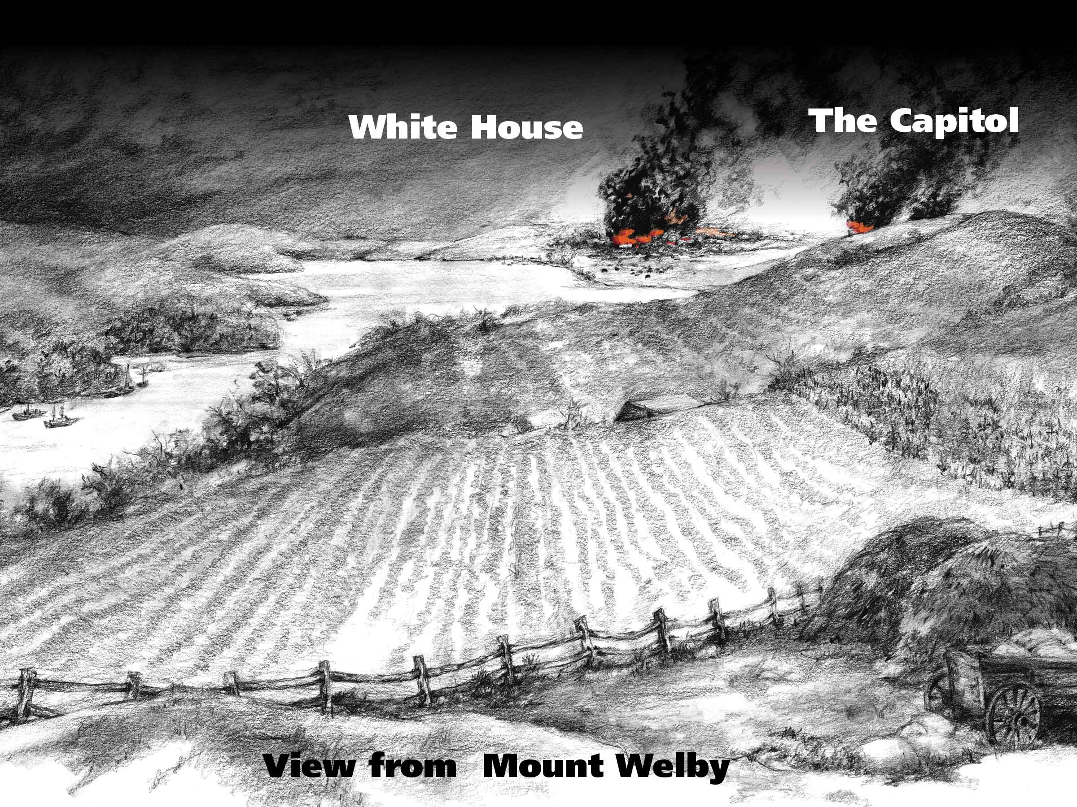

Procedure
Part 1.
Reviewing The Star Spangled Banner
Activity 1: Discussion and Analysis
Read The Star-Spangled Banner and discuss each line in the first stanza.
Activity 2: Review and Map Identification
Review the song's historical context with the students and point out the following locations on a classroom map: Upper Marlboro, Bladensburg, Baltimore, Fort McHenry, and Mount Welby (present day Oxon Cove Park/Oxon Hill Farm), home of the DeButts family.
- Ask students where your school is located in relationship to these sites.
- Explain to students why Francis Scott Key was on a British ship during the Battle of Baltimore and bombardment of Fort McHenry.
Activity 3. Analysis and Research

Part 2:
Oxon Cove Park and The Star Spangled Banner
Activity 1: Viewing The Resources
- View the excerpt of Mrs. DeButts' letter that highlights the discovery of Congreve Rockets on the Mount Welby hillside.
- View the brochure for the Star-Spangled National Historic Trail. Take a look at the map in the brochure on the British advance up the Potomac River.
- View interpretive recreation of the 1814 sight-lines from Mount Welby to Washington, DC
Activity 2: Writing
Ask students to draw a picture or write a story on how they would have felt, as an American citizen, to find a British congreve rocket on their hill. Remind the students that a congreve rocket is what Francis Scott Key refers to in The Star Spangled Banner when he writes about the " rockets red glare."

Part 3:
Putting It All Together

Lesson Plan
Activity1: Writing
- Review The Star-Spangled Banner, the passage from the Mrs. DeButts letter, and the background materials for this lesson plan.
- Instruct students to wirte about two different perspectives of the War of 1812.
Francis Scott Key
Mrs. DeButts
- Do you think Mrs Debutts would have thought The Star-Spangled Banner an appropriate choice for our National Anthem?
Tell students that they must provide examples from both texts to support their product.

All this information came from the National Parks Service Website. Go here for the online resource: https://www.nps.gov/oxhi/learn/education/classrooms/mount-welby-during-the-war-of-1812.htm

